Database Implications:

1. Usability

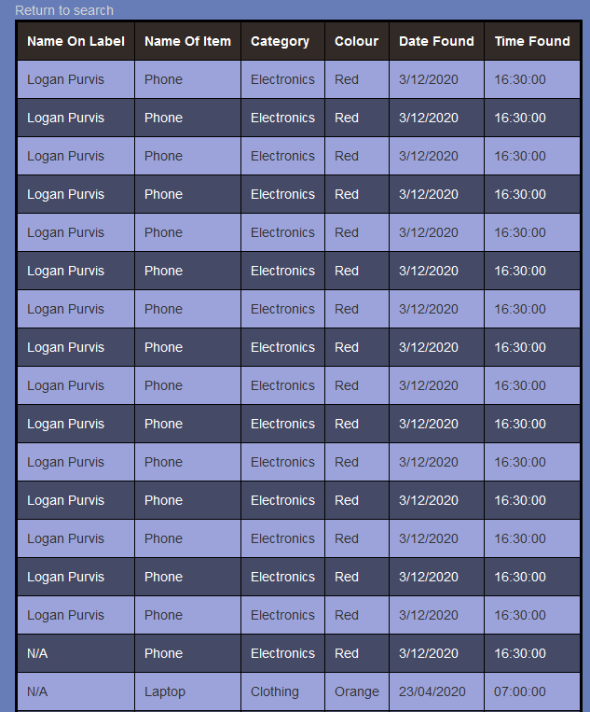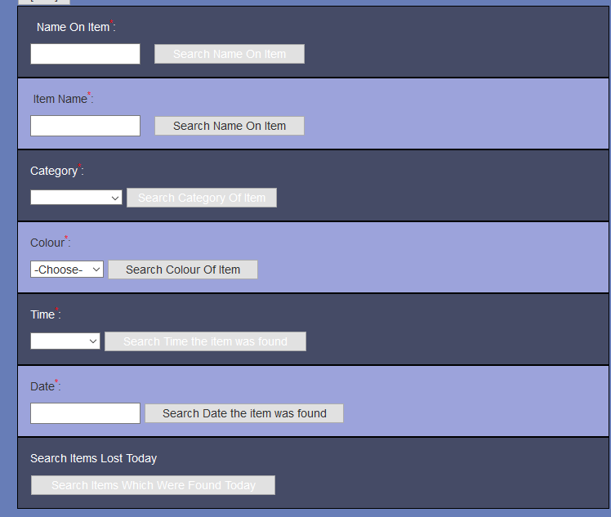Usability is defined by the ability for a digital outcome to be easily accessed and operated by an end user. For a database, its’ usability will be defined by the database’s ease of access to be queried and viewed. I have met this goal by incorporating simple but effective search functions into my website. The results are then displayed in a easy to read, table divided by colour.

Search Functions

Result Functions

1. Privacy

Privacy is defined by the ability for a digital outcome to protect the personal data of its’ users. For a database, Privacy in terms of a database would be defined by extent at which the database would be able to store data securely (with encryption), or by simply not storing any sensitive data. My database meets this goal by doing the latter. I simply do not store any valuable data, and only store insensitive information. (The most sensitive data I store is the name on the label.)

1. Accessibility

Accessibility is defined by the ability for the end user to read the information present in the digital outcome. For a database, Accessibility in terms of a database would be defined how readable the data is for a user. My database meets this goal, by formatting all of my data into easy to read strings, (the date field is in an easy to read dd/mm/yyyy format standard to NZ)

Website Implications

1. Aesthetics

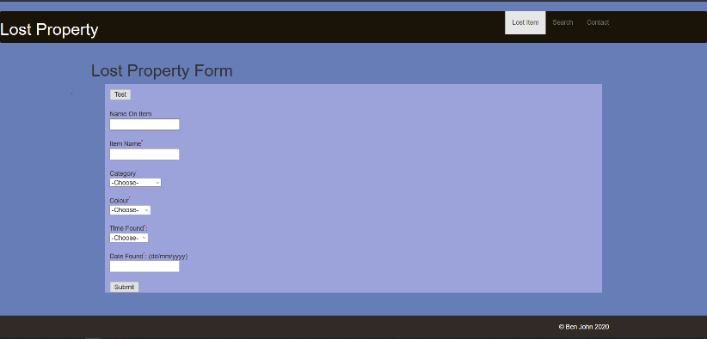Aesthetics is defined by the visual appeal of the digital outcome. For a website, this will include the colour pallet of the website, as well as the layout and design of the website. I have met this by using a minimalist website format with a uniform colour pallet.

Website Layout

Colour Pallet

1. Usability

Usability is defined by the ease of use of the digital outcome for the end user. For a website this will include the layout and design of the website, as well as how well it follows standard website conventions. I have met this goal by laying out my website in a common layout (navbar at the top, body, footer). This allows the user to quickly navigate the website, as they are likely to be familiar with the website layout without necessarily being familiar with the lost property website.

1. Functionality

Functionality is defined by the ability of the digital outcome to perform it’s intended purpose. For a website, this will involve the website’s ability to search, and display data, as well as preventing the user from entering invalid data, that may compromise the database’s functionality. I have met this goal by ensuring that my website is able to correctly link to other pages, and validate all of the information that is entered in the database. All of the links display the information correctly as well as the tables.